I think 6 graph/charts on the UI

* + Pie charts for the proportion of bandwidth usage for each application
  + Pie chart for User Happiness
  + Print out packet loss
  + Print out analytics in a table or data frame
  + Bell chart on background data for STD and mean
  + Variance bar plot
  + Add bandwidth amount on y-axis and time on the x-axis

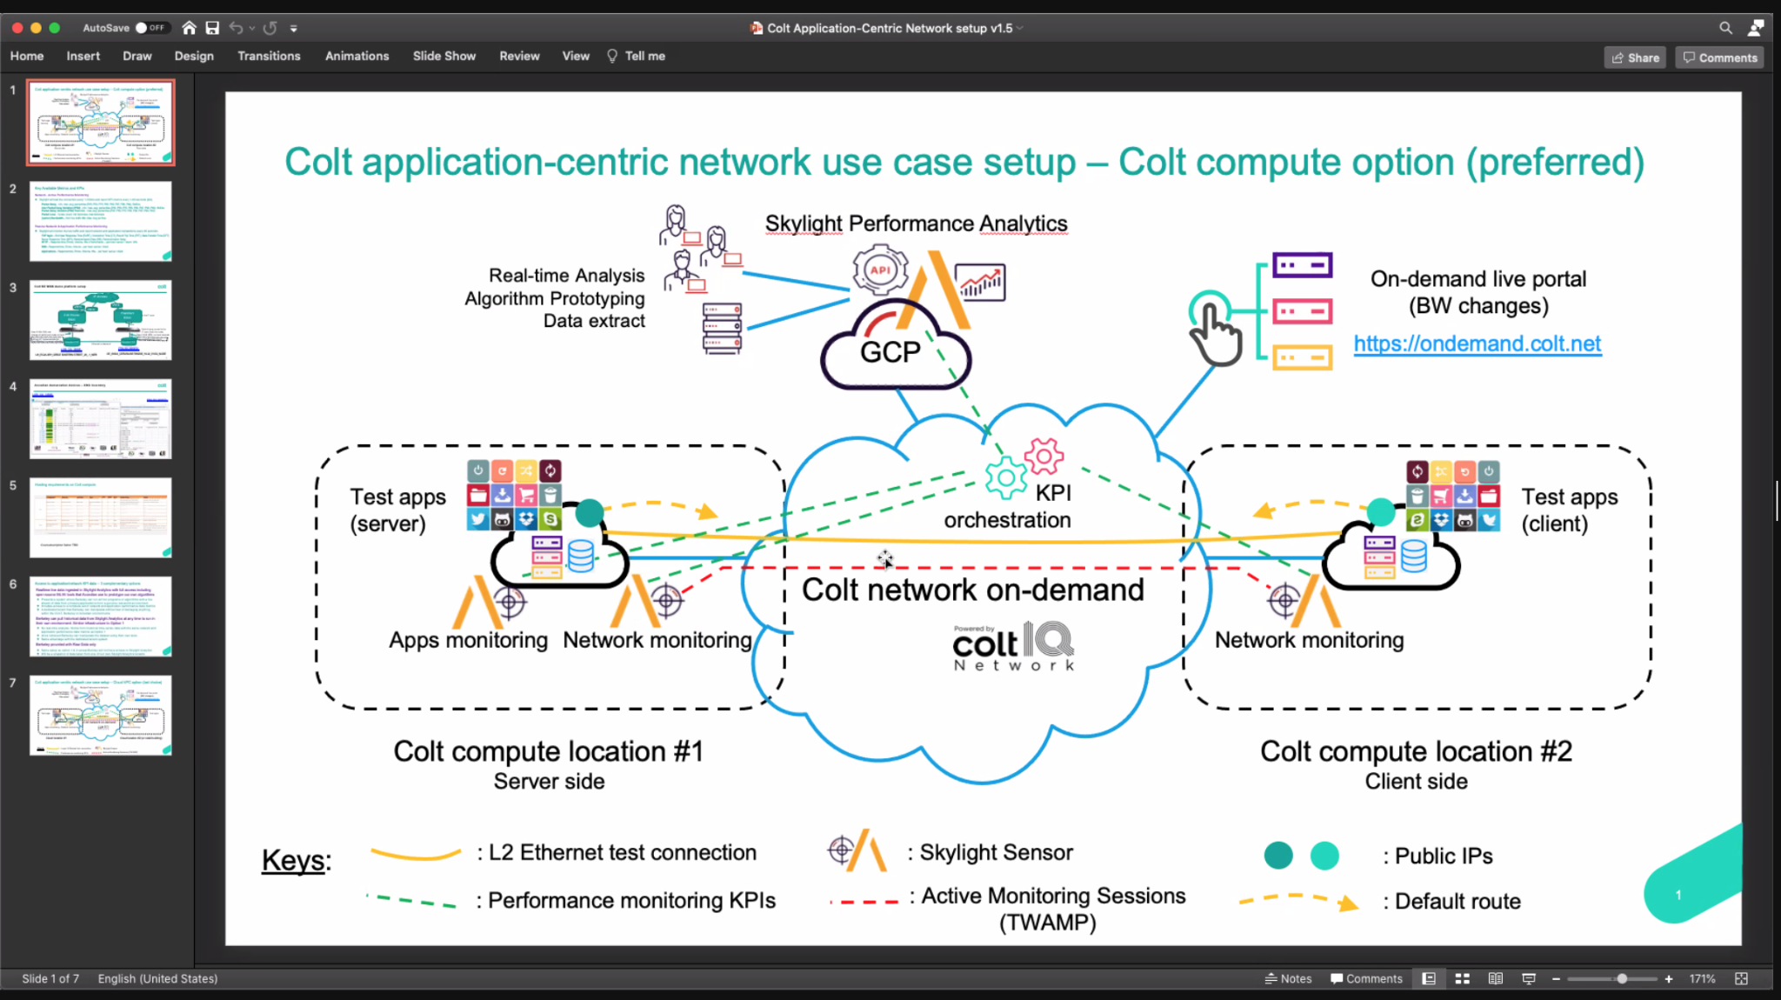

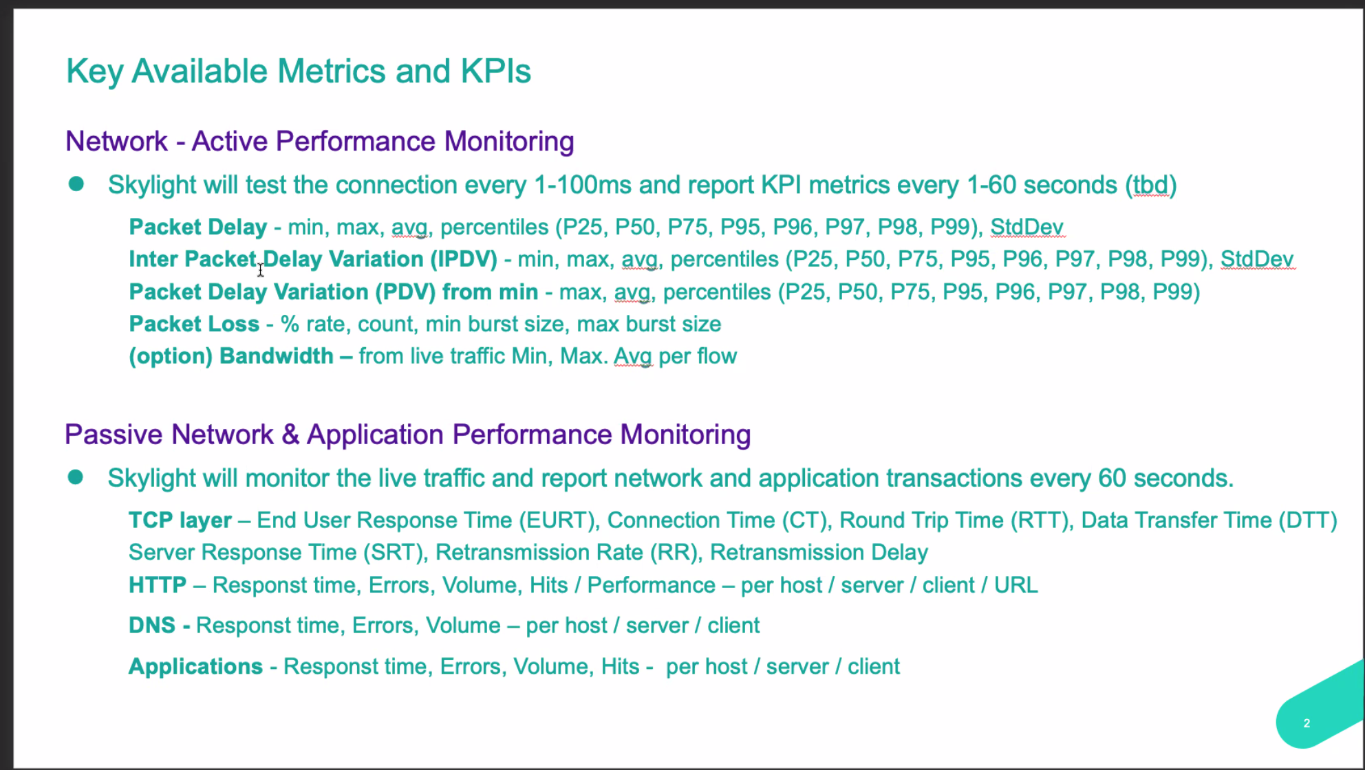

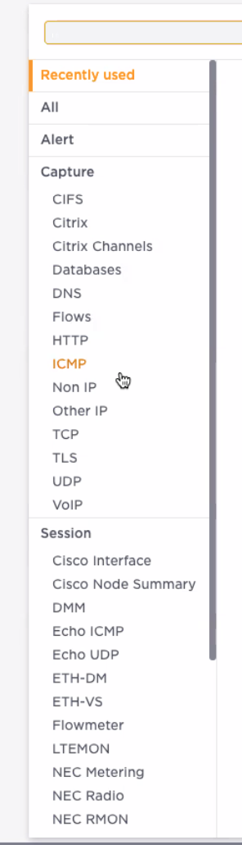

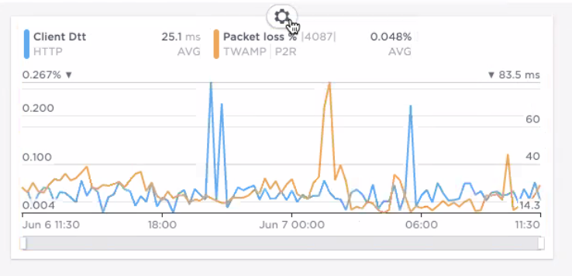

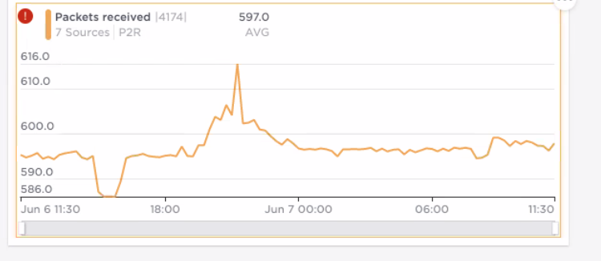



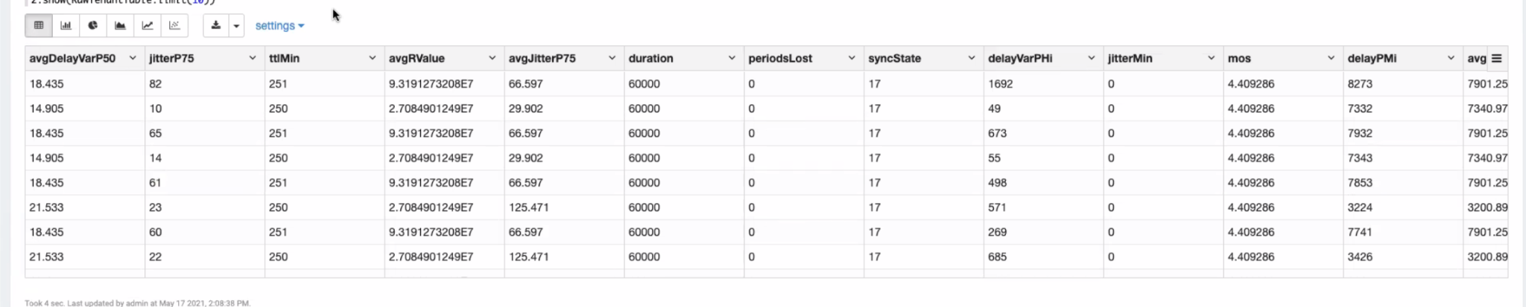



User experience in the pie chart is available

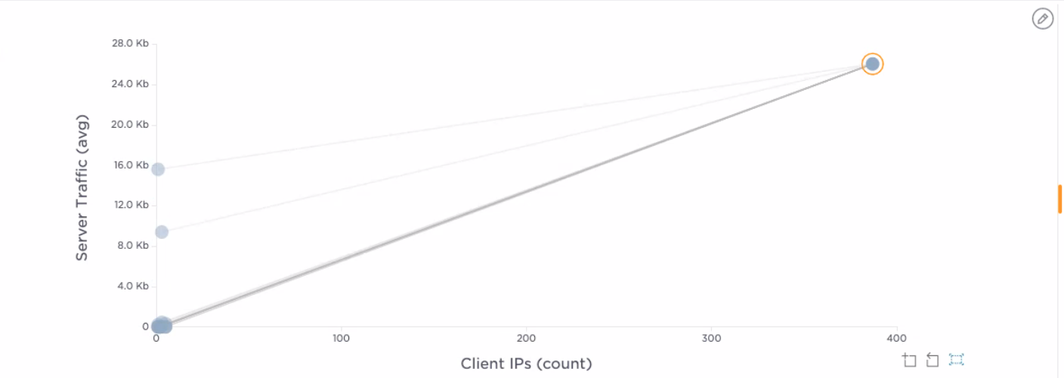

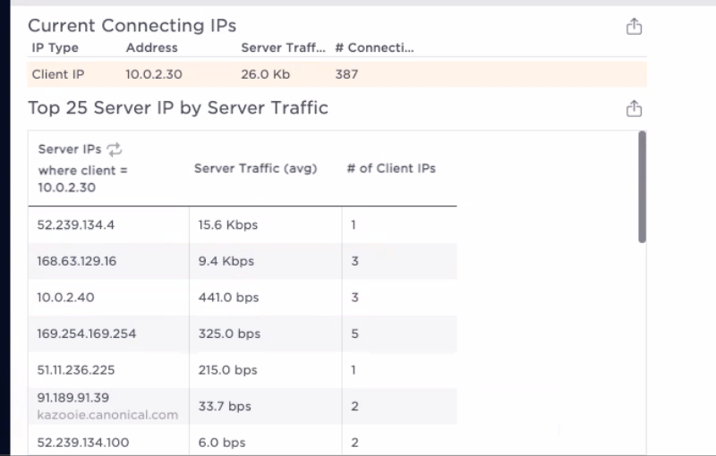

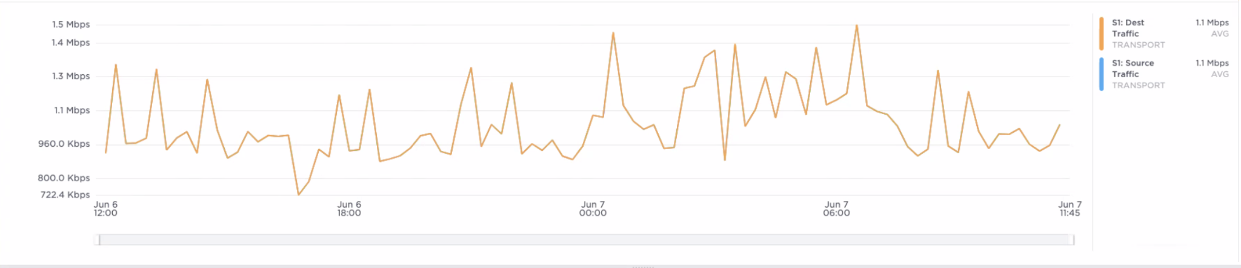



Sample UI/ Rough draft

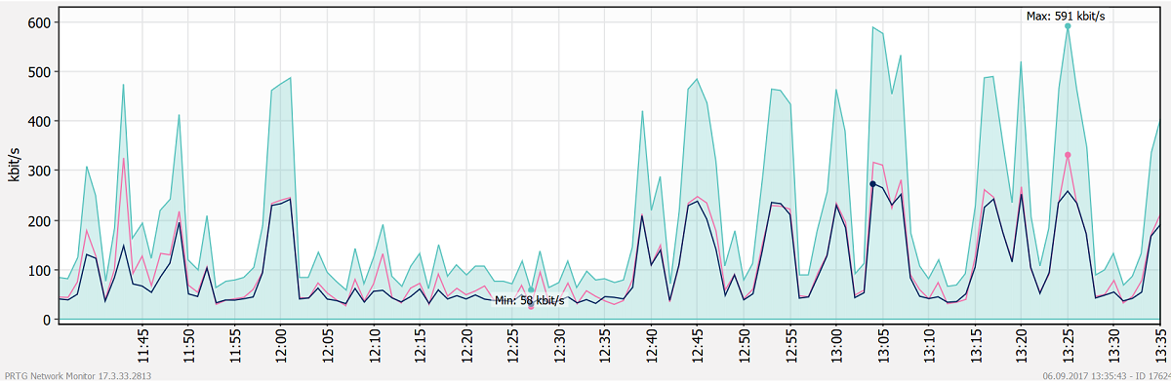

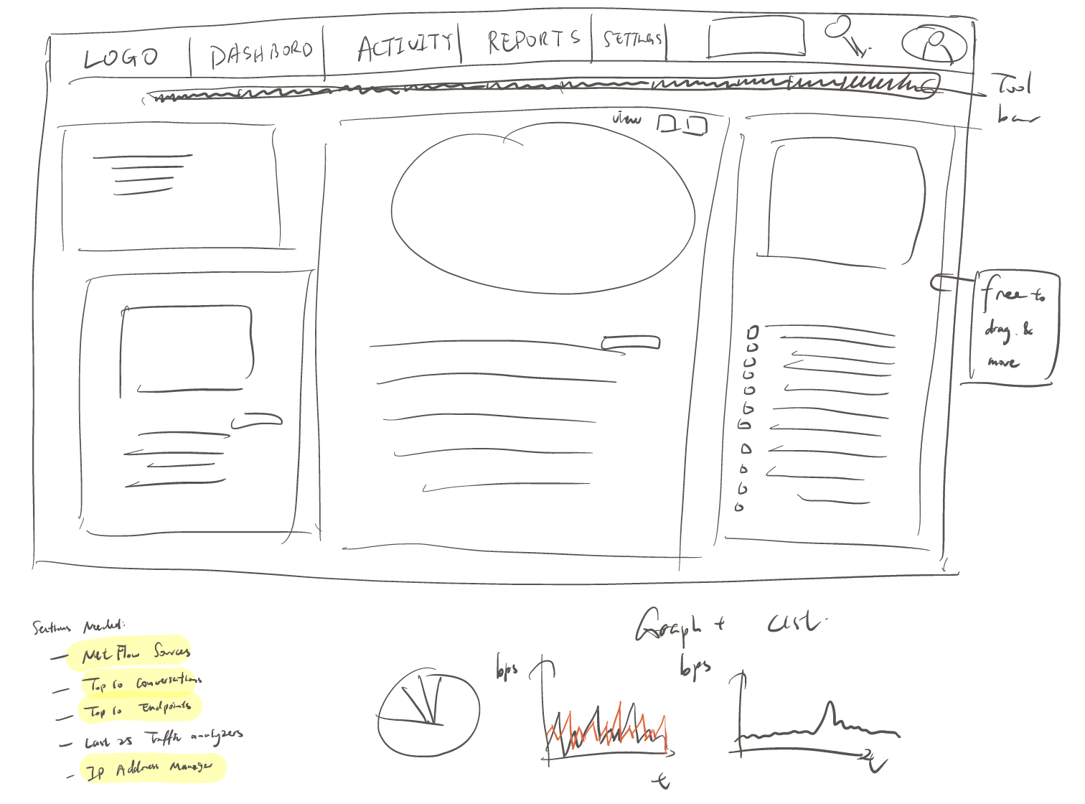

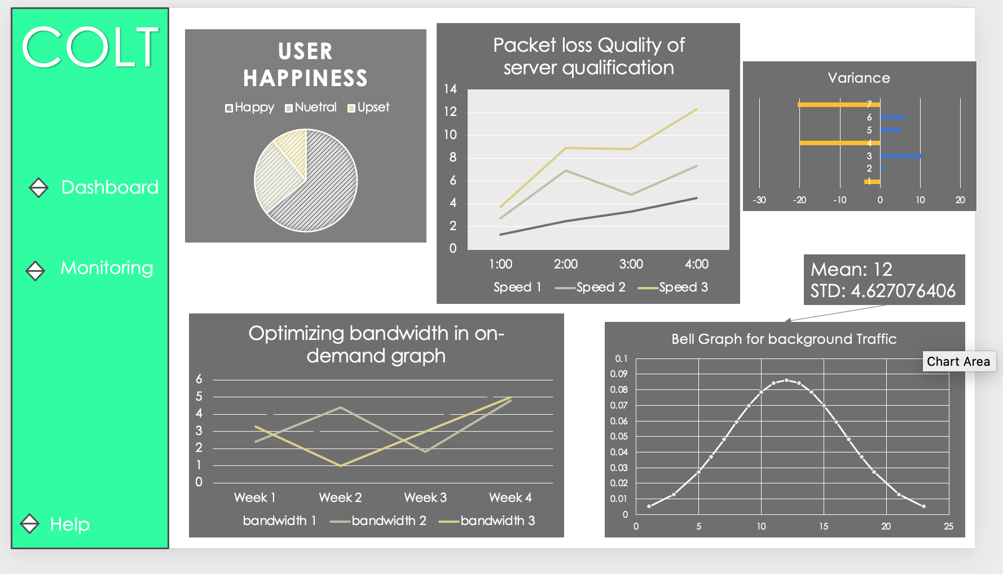

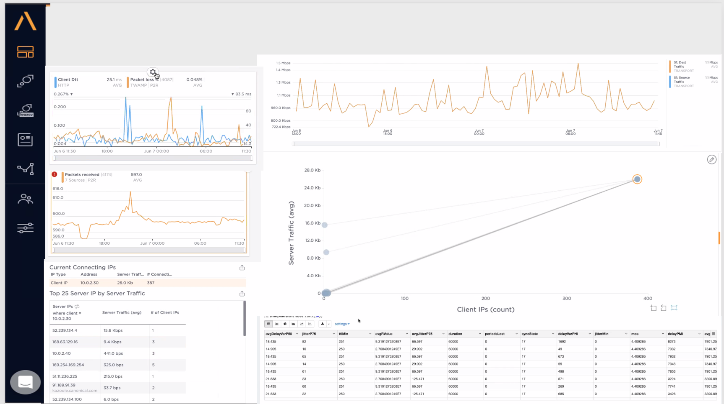

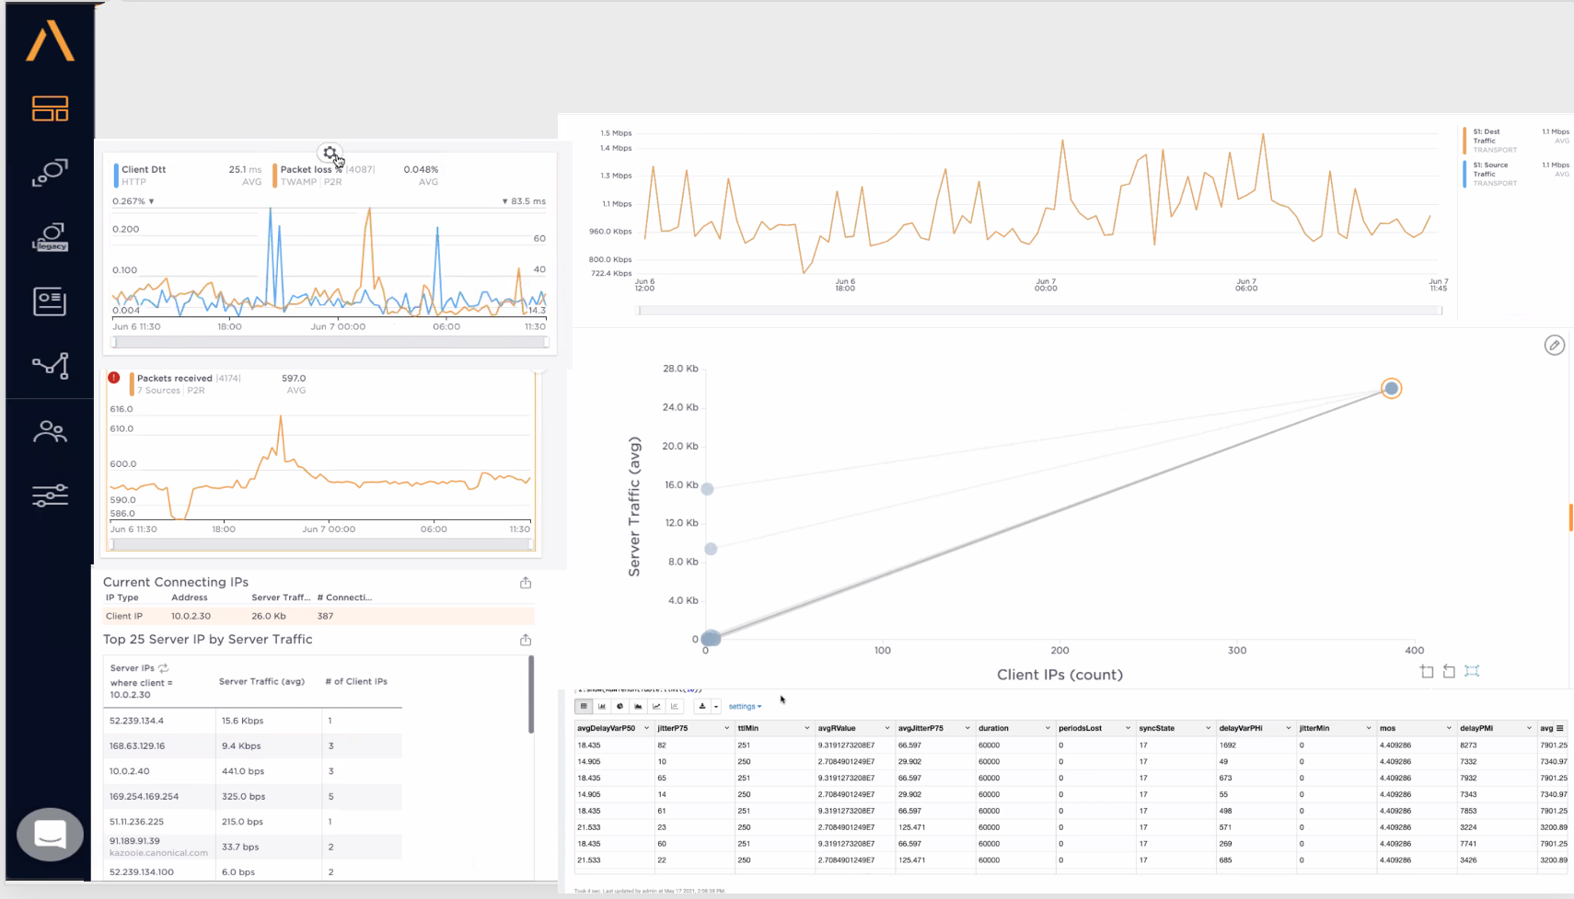

table